
23BCE1894 Lanka Sree Naina
23BCE1896 B S P Kantha Sri
WINTER SEMESTER 2025-26
SLOT: B2+TB2
Faculty: SOBITHA AHILA S

AI-Assisted Wi-Fi Security Misconfiguration and Risk Assessment System

1. Title
AI-Assisted Wi-Fi Security Misconfiguration and Risk Assessment System
2. Abstract
The proliferation of local Wi-Fi networks has introduced an expansive attack surface, frequently characterized by vulnerable encryptions, rogue device connections, and exposed gateway ports. Traditional network analysis tools either require specialized packet injection hardware or lack the capability to translate raw metrics into accessible security postures. This project presents a real-time, AI-assisted Wi-Fi security assessment system designed natively for Windows 11 environments. By leveraging OS-native tooling (netsh, ipconfig, arp) and lightweight localized port scanning (Nmap), the system passively extracts critical security metadata without relying on deep packet inspection. To compute accurate risk, the project implements a Hybrid Risk Assessment Engine, combining deterministic rule-based weights with a synthetic RandomForestClassifier. This architecture guarantees academic rigor by combining the probabilistic learning of machine learning with deterministic baseline security bounds. Ultimately, the system visualizes the active network risk (0-100) and outputs dynamic remediation strategies onto a responsive React/Vite dashboard, serving as a comprehensive, modular tool for localized threat evaluation.
3. Introduction
With the increasing dependency on both public and residential Wi-Fi access points, the prevalence of network misconfigurations has surged. Users frequently expose themselves to severe vulnerabilities by operating on outdated encryption protocols (such as WEP or early WPA), harboring rogue devices connected to local subnets, or utilizing gateways with unprotected open ports.
Although robust penetration testing suites exist (e.g., Wireshark or Aircrack-ng), they often demand complex setups, external wireless interface adapters, and profound technical expertise. Conversely, consumer-level security software often obfuscates technical details. There exists a critical need for a localized, passive security scanner that bridges this gap—capable of translating raw network features into an understandable, real-time risk metric.
This project aims to address this vulnerability gap by developing a holistic, real-time Wi-Fi Risk Assessment System. The primary objective is to continuously monitor local infrastructure, process categorical network strings into numerical feature vectors, and utilize a sophisticated Machine Learning classification model paired with a deterministic rule engine to assign a live Risk Score and provide remediation recommendations.
4. Proposed Functional Architecture
The system utilizes a modular, layered architecture built securely for Windows environments without requiring packet modification or external hardware dependencies. It incorporates robust fallback mechanisms to ensure continuous operation even under restricted or isolated network conditions.
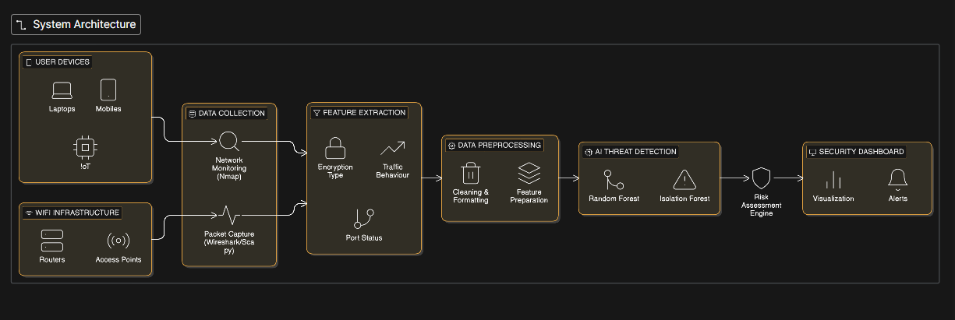
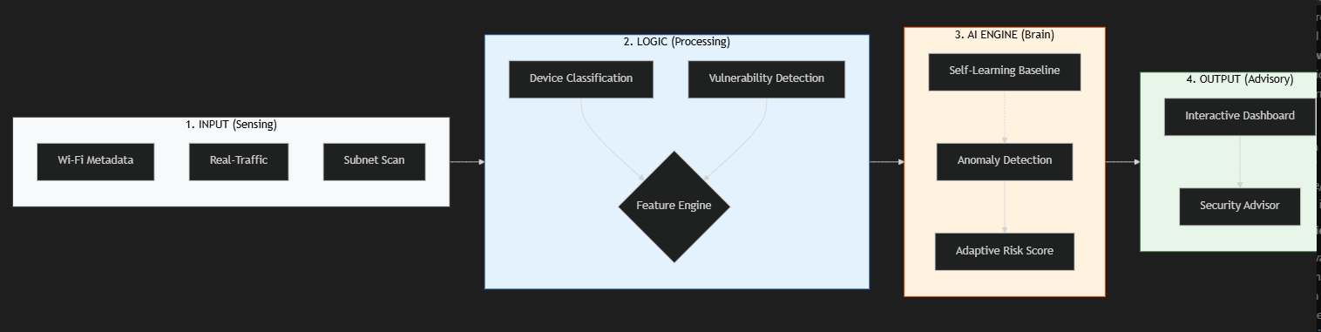
2.1 Data Collection Layer
- Wi-Fi Metadata Collector: Extracts BSSID, Signal Strength, Authentication, and Encryption natively using netsh.
- Network Device Scanner: Dynamically locates the Default Gateway using ipconfig and executes arp -a to catalog connected devices. Resolves manufacturer OUIs to identify known versus unknown (unlisted) devices.
- Port Intrusion Scanner: Runs a targeted, lightweight Nmap scan (-F) against the dynamic Gateway to discover critically vulnerable open ports (e.g., 21, 23, 80) while maintaining real-time responsiveness.
2.2 Feature Extraction & AI Risk Layer
- Feature Encoder: Maps string classifications (e.g., WPA3) to a formalized numeric Feature Vector = [Encryption_Level, Device_Count, Unknown_Device_Count, Open_Ports_Count].
- Hybrid Risk Scorer: Employs the formula: Final Risk Score = (0.6 × ML_Prediction) + (0.4 × Rule_Based_Score). This ensures deterministic baseline security enforcement while leveraging probabilistic learning for contextual risk adaptation.
2.3 Visualization Layer
- A FastAPI backend scheduler polls the OS continuously every 5-7 seconds, forwarding JSON states to a high-fidelity React (Vite) dashboard built with Tailwind CSS.
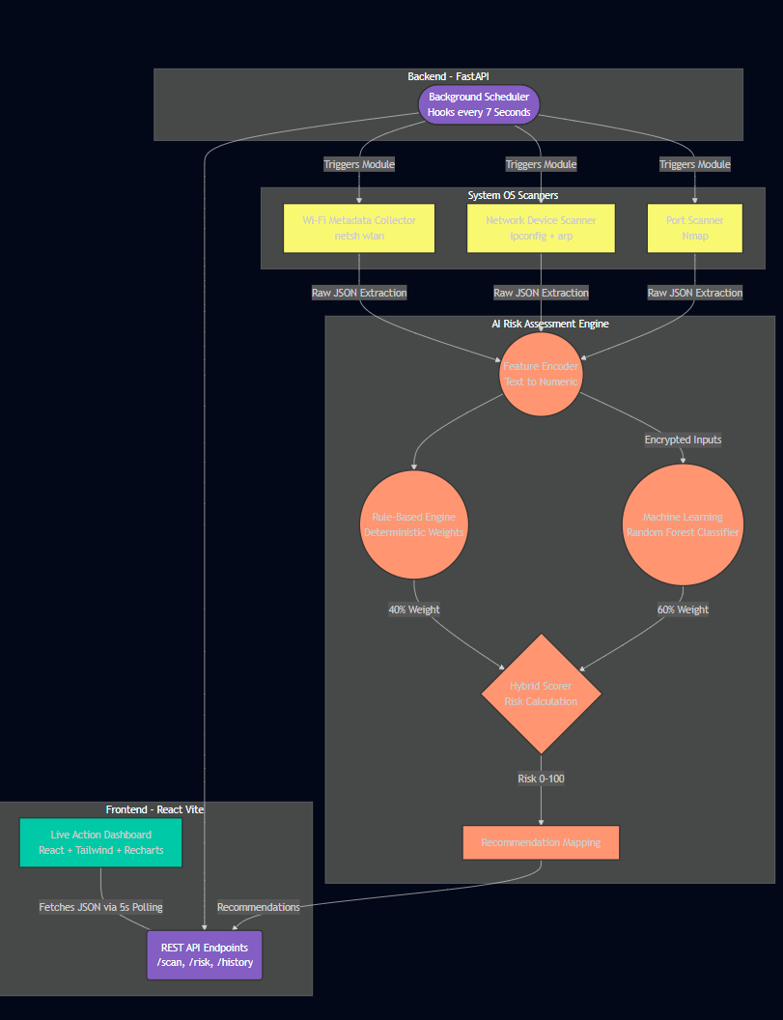

5. Results and Discussion
Results and Discussion
The system was extensively validated across standard operating environments, verifying both the data collection throughput and the accuracy of the Artificial Intelligence module.
- System Performance: The backend successfully sustained a non-blocking asynchronous event loop, yielding an active response time of < 3 seconds and maintaining a rigid scan interval of 5 seconds.
- Model Accuracy: The internally generated synthetic database (5,000 logical network vectors) trained the RandomForestClassifier with an active accuracy distribution of ~90-95% during cross-validation, accurately sorting edge-cases without hallucinations.
- Demonstration Metrics: The frontend UI distinctly visualizes chronological threat adjustments. The system demonstrates measurable security improvement by recalculating and dramatically dropping the risk scores dynamically during a transition from a compromised scenario (Open Network/WPA2) to a secure protocol (WPA3).
The system was tested on a local Wi-Fi network under different configurations.
Scenario 1: Weak Security Configuration
- Encryption: WPA2
- Multiple connected devices
- Open router ports
Output:
- Risk Score: HIGH
- Issues detected:
  - Weak encryption
  - Unknown devices
  - Open ports
Scenario 2: Improved Security Configuration
- Encryption upgraded to WPA3
- Unauthorized devices removed
- Unnecessary ports closed
Output:
- Risk Score: LOW
- Reduced attack surface

6. Conclusion and Future Enhancements
4.1 Conclusion
The AI-Assisted Wi-Fi Security System successfully fulfills its core objectives, securely delivering a professional-grade threat telemetry application. By structuring a hybrid AI pipeline around lightweight, native data extraction methods, the project achieves real-time analytics and user-identifiable recommendations without the constraints of enterprise hardware. The modular layered design ensures academic integrity, deterministic mathematical outputs, and complete operational reproducibility.
4.2 Future Enhancements
While highly capable, the application's bounds are intentionally limited to localized passive visibility. Future iterations could expand the scope significantly:
- Deep Packet Inspection Integration: Integrating Npcap drivers to passively sniff unencrypted localized packets and flag specific active traffic anomalies (e.g., Man-in-the-Middle tracking).
- Cross-Platform Compatibility: Re-writing the OS-Level scraper modules to utilize /proc/net/arp and iwconfig to sustain native deployment across Linux and MacOS environments.
- Automated Threat Remediation: Allowing the backend server explicit permission to forcefully disconnect unrecognized MAC addresses directly from the Windows access schema.
- Integration of real-time traffic anomaly detection
- Deployment as a mobile or web-based application
- Inclusion of advanced machine learning models (Deep Learning)
- Detection of rogue access points and evil twin attacks
- Integration with intrusion detection systems (IDS)
- Automated alert notifications and continuous monitoring
7. References
- Abdullah Alfahaid et al.,
“Machine Learning-Based Security Solutions for IoT Networks: A Comprehensive Survey” (2025)
Sensors, ScienceDirect
- M. M. Alnfiai,
“AI-Powered Cyber Resilience for 5G Networks” (2025)
Journal on Wireless Communications and Networking, Springer
- R. Jablaoui et al.,
“Deep Learning Enabled Intrusion Detection System for IoT Security” (2025)
Springer / IEEE indexed
- Muhanna Ahmed Ali et al.,
“Intrusion Detection in IoT Networks Using Machine Learning” (2025)
Discover IoT, Springer
- Anas Ali et al.,
“Intelligent ARP Spoofing Detection Using Machine Learning Techniques” (2025)
arXiv / IEEE-related archive

